Chennai.-600077
From
SARAVANAVENKATESAN.S. -9840680556,
Skype id- saravanavenkatesan.s –
E-mail ID: saravanavenkatesan@yahoo.co.in
saravanavenkatesans@gmail.com
To
The Principal, /Head Master, /Secretary, /Correspondent,

Respected Sir / Madam,

I am saravanavenkatesan.S, Online Tamil Language teacher, Chennai. I am having 10 years teaching

Experience in school syllabus and 6 years online teaching experience. I Cam able to teach through

Skype/Google meet and also web link if any provided. Except school syllabus, I am taking

classes on Spoken Tamil, Thirukkural with English explanation Related story, Aathichudi,

Aasarakkovai etc.

I attached herewith my detailed Resume and copy of certificates.

Thanks and regards

Saravanavenkatesan s Skype id - WhatsApp cell-9840680556-

Add
Online Tamil / Classes through Skype

Qualified Tamil Pundit with 15 years teaching experience. Online Teaching - Spoken Tamil to Indian origin students in US/Canada through Skype. Teaching syllabus includes - Devaaram, Thiruvasakam, Thirukkural, Aathichudi, Naladiyar, ThiruMandiram Ulaganeethi Integrated teaching mode through audio / video / pictures with related English content. Teaching Faculty : Saravanavenkatesan. S Cell - (091) 9840680556 Skype Id. saravanavenkatesan.s
Contact Person saravanavenkatesan
Address
Phone Cell-9840680556
Email saravanavenkatesan@yahoo.co.in
Website skype Id. saravanavenkatesan.s

Thanking You,
Yours sincerely,
Saravanavenkatesan.S Enclosed. : Certificates photoset copies
&
9840680556
Resume.

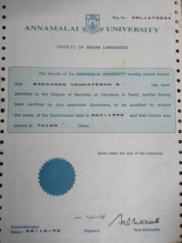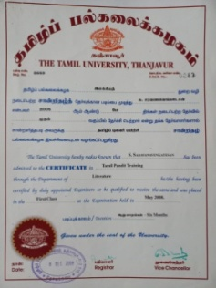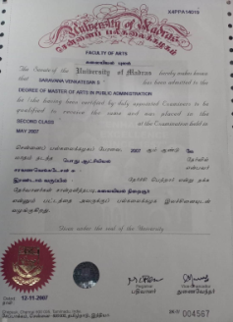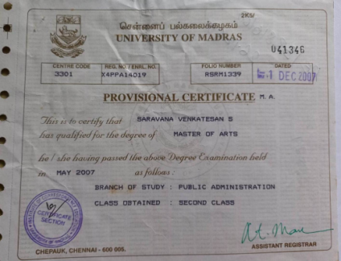

RESUME

NAME : SARAVANAVENKATESAN.S.
FATHER’S NAME : LATE SRI.V.SUBRAMANIAN.
ADDRESS : Skype id- saravanavenkatesan.s
E-mail ID: saravanavenkatesan@yahoo.co.in
WhatsApp –Cell -9840680556-

NATIONALITY : INDIAN
RELIGION : HINDU
CASTE : BRAHMIN
MARITAL STATUS : MARRIED.
CONTACT No : 9840680556
EDUCATIONAL
QUALIFICATION : B Lit. Tamil, MA, Finished Tami Pundit Training
With first class.(Thanjavur Tamil University)
E-mail ID : saravanavenkatesan@yahoo.co.in
Skype id : saravanavenkatesan.s
LANGUAGE KNOWN : Tamil & English
EXPERIENCE : * 12 Years Experience as Tamil Pundit
* Seven years Online Teaching Experience
* I have experience in Private TV Educational Programme,
namely, ‘Dinam Oru Thirukkural’ with related moral story.
& conducted Tele Quiz Live Program-GK.
-------------------------------------------------------------------------------------------------------------------------
Yours sincerely,

Saravanavenkatesan,
9840680556 .
Place: Chennai -77. .

